TRAY WHITENING

Q What does tooth whitening do?


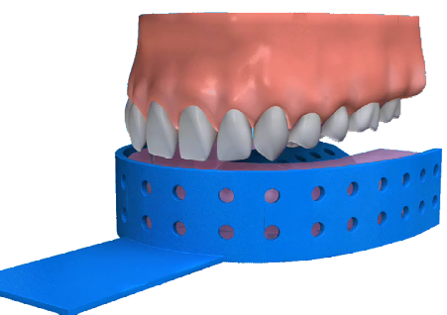
A Tooth whitening can be a highly effective, yet very simple way, of lightening the colour of teeth without removing any of the tooth surface. It cannot make a colour change, but lightens the existing colour.

Q What does the procedure involve?

A In a live tooth the dentist applies the whitening product using a specially made tray which fits into the mouth like a gum shield. The chemical is then activated using heat, or heat and light combined. The active ingredient in the product is normally hydrogen peroxide or carbamide peroxide.

If the tooth has been root treated, the canal, which previously contained the nerve, may be reopened and the whitening product is put in.

In both cases, the procedure needs to be repeated until the right shade is reached.

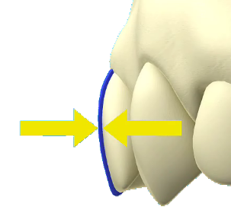
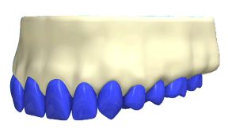
Q How long does the procedure take?

A First of all you will need 2 or 3 visits to your dentist. Your dentist will need to make a mouthguard and will need to take impressions for this at the first appointment. Once your dentist has started the treatment, you will have to continue the treatment at home. This will mean applying the bleach regularly over 2-4 weeks for 30 minutes to 1 hour at a time.

However, some newer products can be applied for up to 8 hours at a time, which means that a satisfactory result can be obtained in as little as 1 week.

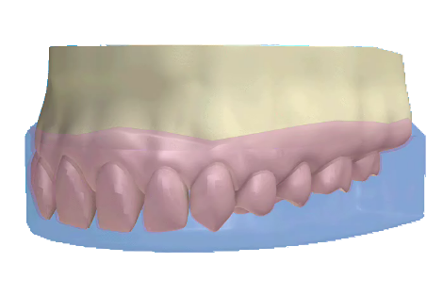
Q Why would my teeth need to be bleached?

A Everyone is different; and just as our hair and skin colour varies, so do our teeth. Some teeth have a yellowish tinge, some are more beige – very few are actually ‘white’. Teeth also yellow with age can become stained on the surface by food and drinks such as tea, coffee and blackcurrant. Calculus (tartar) can also affect the colour of the teeth. Some people may have staining inside their teeth. This can be caused by certain antibiotics or tiny cracks in the teeth, which take up the stain.

Q Will I be happy with the results?

A Treatment results may vary depending on the original shade of the teeth. Teeth will tend to darken slightly over time. The effect lasts for around 1 to 3 years, although sometimes it can last longer. Some people find that their teeth are sensitive for the first few days after treatment, but this wears off after a short while.

Q What about home kits?

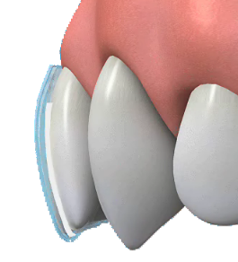
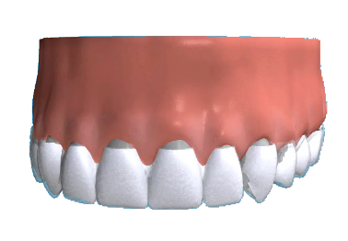
A Over-the-counter kits are not recommended as they contain only a small amount of hydrogen peroxide which makes the product less effective. Some also contain mild acids, while others are abrasive. Although these products are cheaper, whitening is a complicated treatment procedure and should only be carried out by a dentist after a thorough examination and assessment of your teeth. It is very important to follow the instructions your dentist gives you, and to make sure that you go for any follow-up appointments recommended.

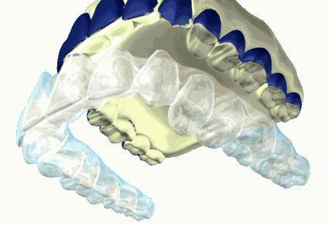

Q When might whitening not work?

A Whitening can only lighten your existing tooth colour. For a change to specific chosen shade veneering is another option. Whitening also works on natural teeth. It will not work on any type of 'false’ teeth. This includes dentures, crowns and veneers. If dentures are stained or discoloured, it may be worth visiting the dentist and asking him or her to clean them. Stained veneers, crowns and dentures may need replacing. Again, ask your dentist.

Q What about whitening toothpaste?

A There are now several whitening toothpastes you can buy. Although they do not affect the natural colour of the tooth, they are effective at removing staining and therefore improving the overall appearance of the tooth. Whitening toothpaste may also help to keep up the appearance, once teeth have been professionally whitened.

